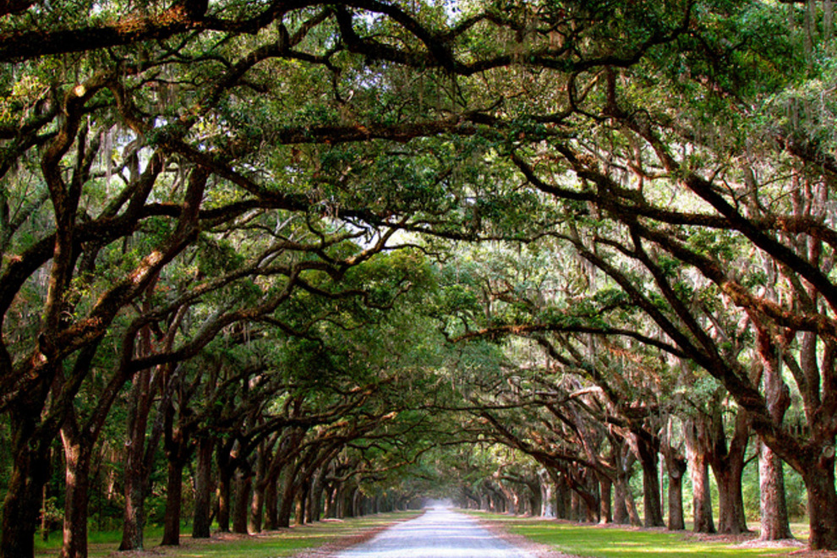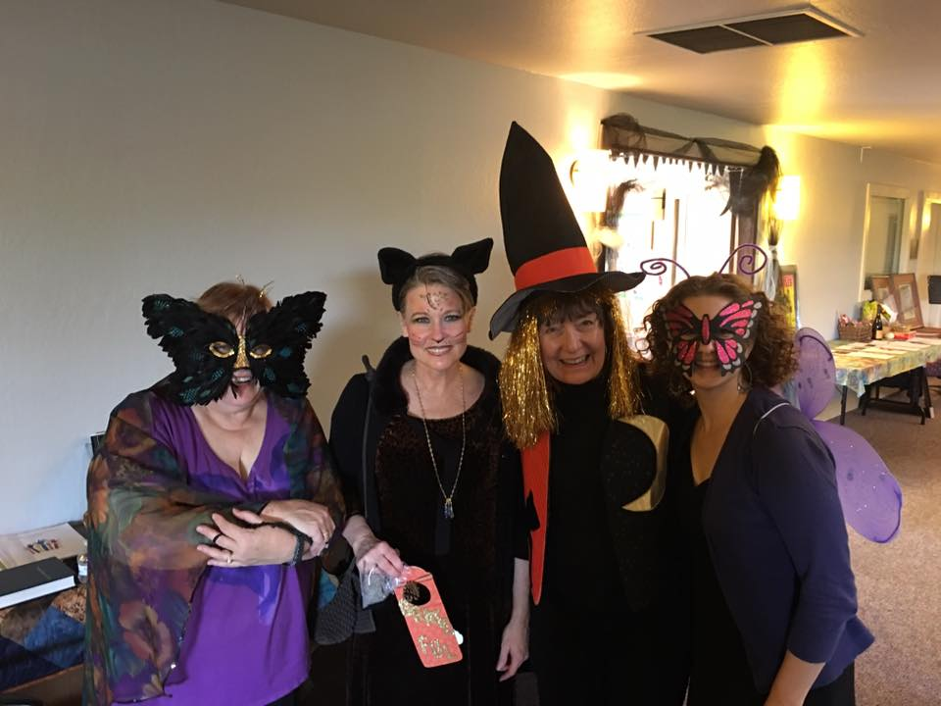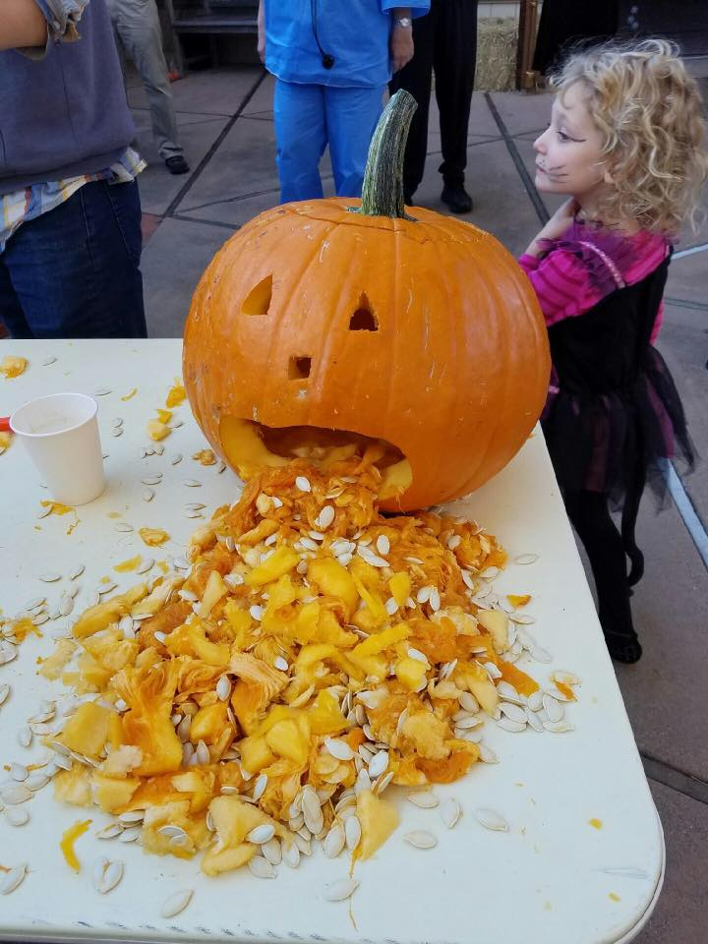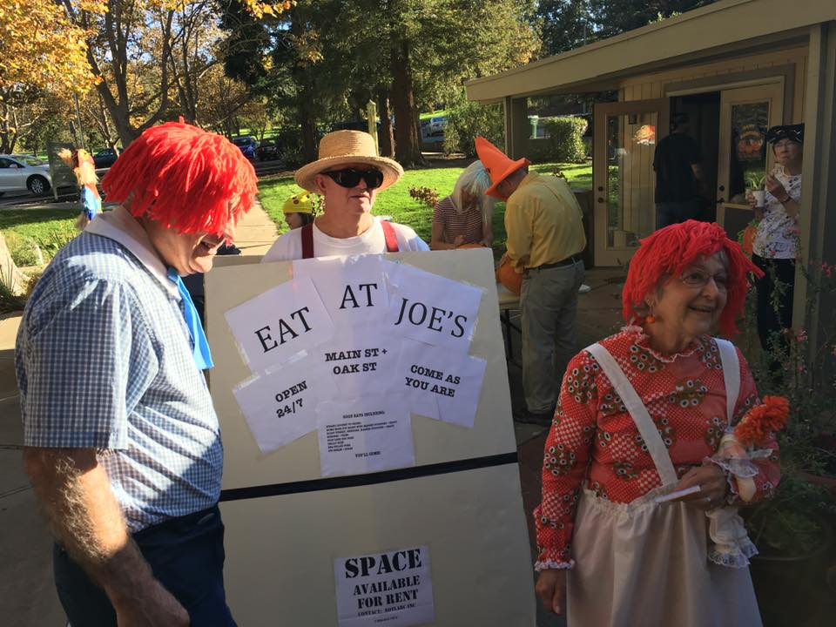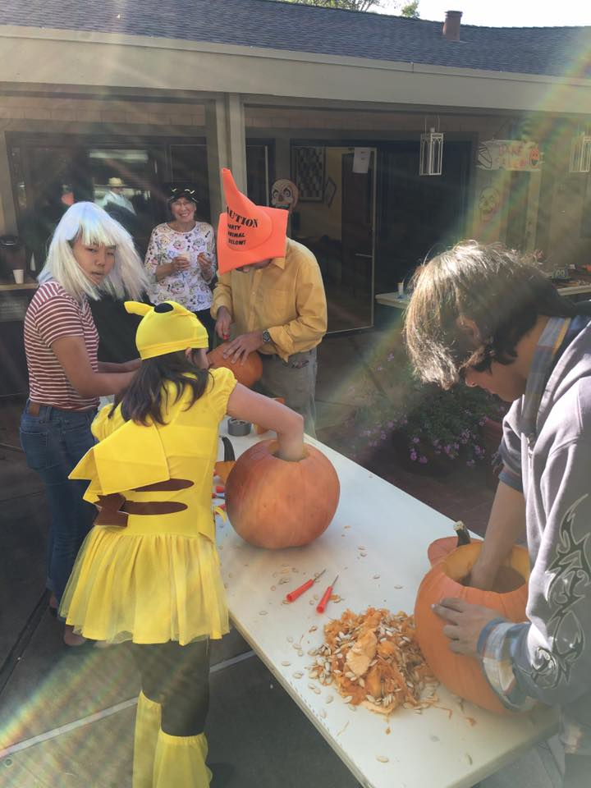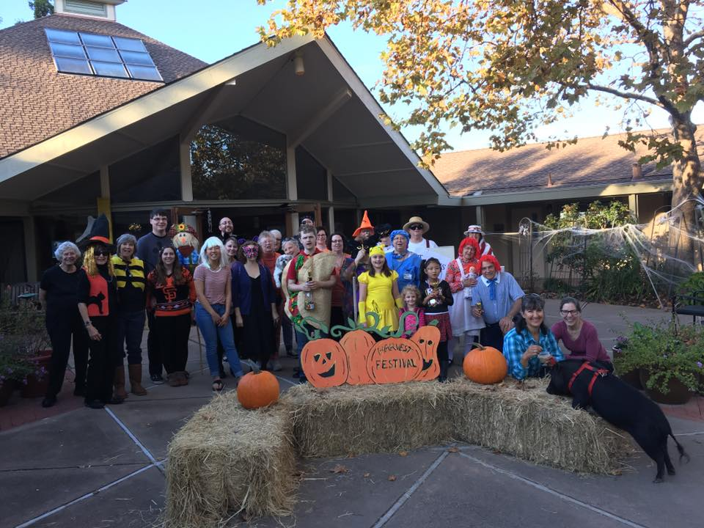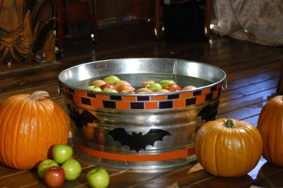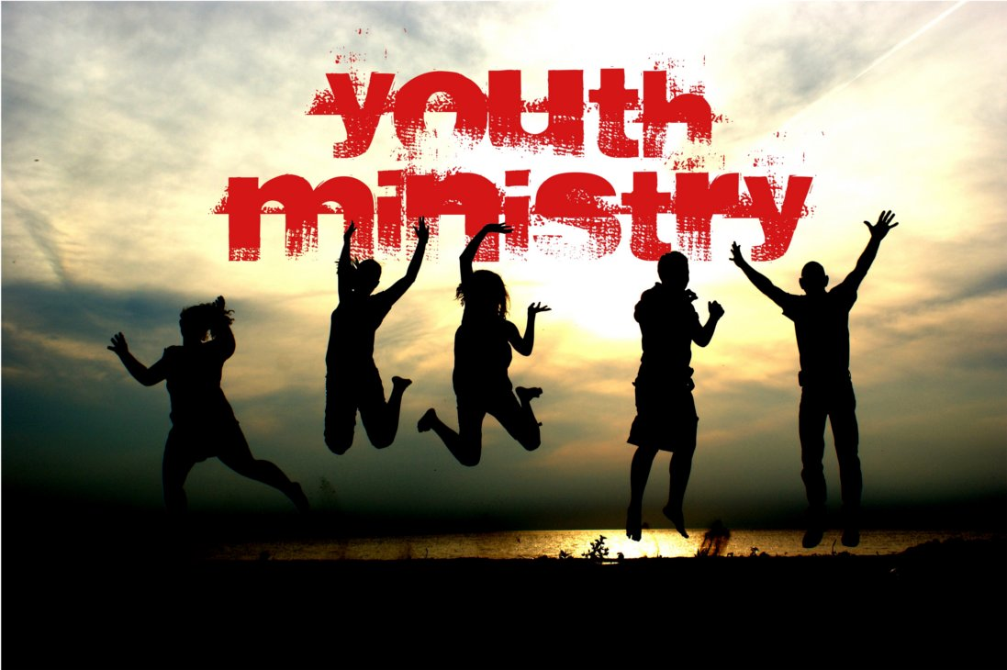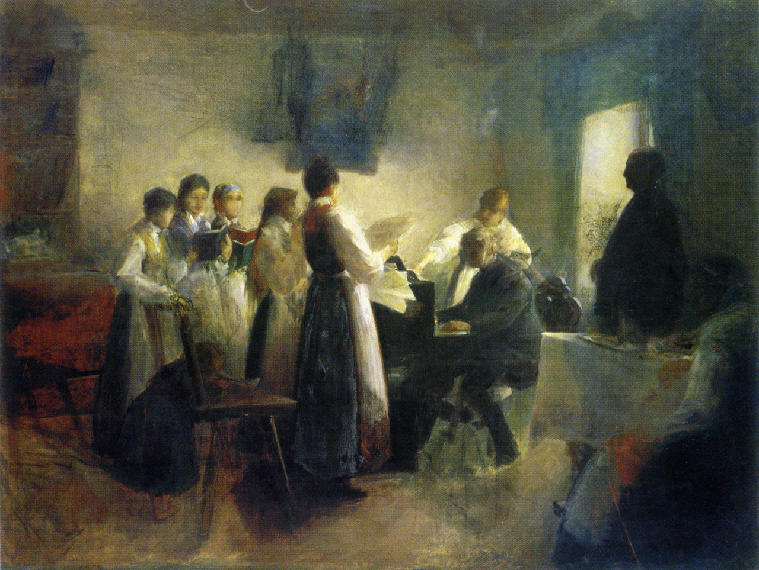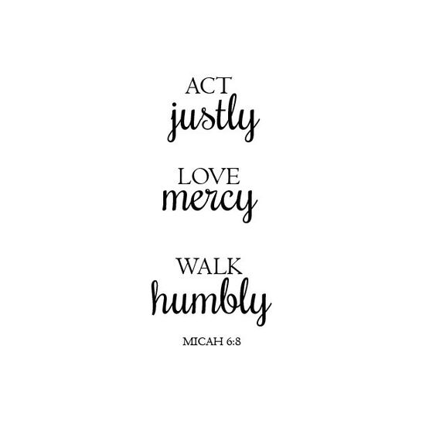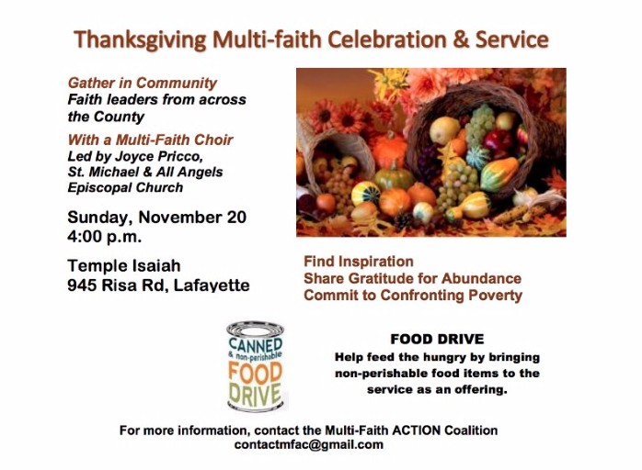

9-Noon - Come on out and help in decorating the church for the holidays!

### Ever been there?

Jolene was only 8 years old and lived with family in the country with her parents and brother.  Consequently they did not often have visitors from the city.  One day Jolene's mother said that father was bringing two guests home for Thanksgiving supper.

After they had enjoyed the turkey, Jolene went to the kitchen to help her mother, and proudly brought in the first piece of pumpkin pie and gave it to her father.  He then passed the plate to a guest.  When Jolene came in with the second piece and gave it to her father, he again gave it to a guest.

This was too much for Little Jolene, who blurted out, “It's no use, Daddy. The pieces are all the same size.”

Source: Unknown

### Words of Encouragement

16Rejoice always, 17pray without ceasing, 18give thanks in all circumstances; for this is the will of God in Christ Jesus for you. 19Do not quench the Spirit. 20Do not despise the words of prophets, 21but test everything; hold fast to what is good; 22abstain from every form of evil.

23May the God of peace Himself sanctify you entirely; and may your spirit and soul and body be kept sound and blameless at the coming of our Lord Jesus Christ. 24The one who calls you is faithful, and He will do this.25Beloved, pray for us. 26Greet all the brothers and sisters with a holy kiss. 27I solemnly command you by the Lord that this letter be read to all of them. 28The grace of our Lord Jesus Christ be with you.

1 Thesselonians 5:16-28

Special Guest preacher Rev. Dr. Nick Carter (Pres. Of the Interim) of ABSW

Business Mtg. Afterwards

##### Hanging of the Greens

The Monthly Newsletter of Shell Ridge Community Church

##### Heifer Sunday

### the

Ridge Runner

NOVEMBER 2016

Preaching Rev. Gwen Young. Heifer Social afterwards.

Sunday 11/13

Sunday 11/20

Saturday 11/26

##### Rev. Dr. Nick Carter

Reflections from a recent vacation!

It’s often surprising when one thinks about where an inspiration or motivation came from. I spent the last week in September in Charleston, S.C. and Savannah, GA. with a side trip to DeWees Island off the coast of South Carolina (yes, there is such a place.) In between horse drawn carriage rides, trolley rides and boat and ferry rides, we also visited several churches and cathedrals. While in Savannah, on a hot and muggy afternoon, we spent an hour or more in the very lovely St. John the Baptist Roman Catholic Cathedral. It was a traditional high ceilinged church that was dimly lit with many stained glass windows and nicely cool in temperature. While my cousin Marilyn wandered around shooting pictures, I rested, sitting in the hard wooden pew. (how thankful I am for our new padded chairs!) I leafed through a hymnal/missal and then picked up a small booklet or a lectionary that was in the rack in the pew in front of me. The title of the opening page was Liturgical Reflections of the Season by Jerry Galipeau, the chief publishing officer of the worship resource booklet. The title of the actual article was “Jubilee Year of Mercy”. He relates the story that when he was in the fifth grade, after having taken piano lessons for two years, he was asked to play the grand pipe organ in his parish church for his Catholic school’s Thanksgiving mass. It was an old pipe organ and took quite a bit of pressure on the keys to get the organ to play.  The memory of the sound that filled the church and the voices of over 500 children singing the hymn “We Gather Together”, stayed with him to this very day. It was the first mass at which he had been the minister of music. He went on to remind parish musicians, whether they be pianists, organists, guitarists, cantors or other instrumentalists that they were not put there to put on a show or delight the congregation with their musical talents. They were there to use their talents for those of us in the pews. The greatest way we can respond to our musicians who faithfully lead us in worship each Sunday is by raising our voices in song with those around us.

Music is an art form that can bring us to realms that the spoken word cannot. For someone who hesitates to sing during the service, your own voice raised in praise may be the inspiration that they need to join in too. Perhaps your one voice will be the spark to get the musical fire going. Lift up your voice and SING!  Always, Karen

Always, Karen DeWeese

“There is virtue in work and there is virtue in rest. Use both and overlook neither.”

― [**Alan Cohen**](http://www.goodreads.com/author/show/19734.Alan_Cohen)

**Karen’s Corner**

**LET’S FEED THE KIDS**

A Multi-Faith ACTION Project with the Inter-Faith Council of Contra Costa County

The Pittsburg Family Center

**ALWAYS NEEDED IN November by the 20th**

Diapers, sizes Newborn, 3, 4, and 5 and Unscented Wipes

Special Needs for November & December because usual Family Market will not be available.

If you would like to help with Thanksgiving and Christmas bags for the families, please bring items to the church by December 11th.

Cleaning Supplies Paper Supplies Personal Items

Splash-less bleach 6 pack of Toilet Paper Hand soaps

409 Paper Towels Lotions

Dish washing soap Shampoo

Detergent Conditioner

***LOOKING AHEAD TO WINTER BREAK****...*

*(2 lb. 8 oz.) jars of creamy peanut butter*

**Whenever we are asking for items to be donated, please bring them to church with you and place them in the narthex. (We check the space often.)**

Thanks for all you do as a part of Let’s Feed the KIDS.

Wendy Neale, Chr.

**No Kids Should Be Hungry**

Though it may not always feel like it; there are so many things to be thankful for in life. Even when we are experiencing deep despair the potential for thanks has its place and abounds, really it does. For some, being thankful is hard. For many it is not. Though there is much to be thankful for; sadly, some see being grateful as a form of weakness—exposing certain vulnerability perhaps. Undoubtedly, some of our past hurts can have tremendous bearing on the frequency to which we give thanks.

As the Thanksgiving Holiday approaches, I would like to invite you into a shared practice. Starting today, Nov. 1st, 2016, I am personally making it a point to go out of my way and intentionally “thank” someone (in the form of a note, an email, or face-to-face) for either who they are or something they’ve done that would warrant an intentional response on my part and I would invite you to do the same. Each day throughout the month of November I would challenge y’all (to include myself) to say, “thanks” daily.

The changes within, as the Spirit leads you into a season of gratefulness will be undeniable. Being thankful is influencing, not just within, but without. Those around you will sense—or see first hand—the intent to go even further still and take on a spirit of thankfulness in your own life. If prayer changes things; I would gladly argue, so does thankfulness.

Being a pastor isn’t easy. I get criticized a lot. You wouldn’t think it, but I do. No one likes being scrutinized or having their life placed under a microscope per se, but I assure you, that one kind and thankful word more than makes up for the criticism. Please don’t misunderstand me. Criticism comes with the territory. I’ve been a minister before—this is an old hat really, but I can attest to how very powerful thankfulness is. I appreciate it and find myself going above and beyond for those who are truly grateful.

Scripture is clear, it states, “give thanks always.”

So, brass tax, there are 30 days in November. That’s means that each of us will have 30 opportunities to really take on this spiritual practice. Each day I would encourage you to prayerfully consider who and/or what it’ll be that’ll warrant your thanks.

I’ve seen other ministers challenge the congregants similarly. I’ve watched entire faith communities come together all the more as a result of doing this. I’ve witnessed forgiveness; healing, exacting care, and celebration take shape because of it. I’ve heard stories of folks having gone to great lengths to show their gratefulness and appreciation for others during this time.

For those of you that might prefer a little bit of direction, might I recommend giving each week a theme of sorts. For example, during week one (11/1-11/5) you might want to plan on thanking those who have made a big difference in your lives (past tense). During week two (11/6-11/12) we might want to concentrate our efforts on thanking those who are making a big difference in our lives today. During week three (11/13-11/19) I might mix it up and concentrate our efforts on identifying those areas in our lives where we have shown little thanks and reverse the pattern... and so on and so on. Point is; this practice will be as creative as we’re willing to make it. I would just challenge each of us to go out of our way to thank someone everyday.

***“Rejoice always, pray without ceasing, give thanks in all circumstances; for this is the will of God in Christ Jesus for you.”***

***1 Thesselonians 5:16-18***

# Rev. Carlton’s Notions

# “Thankfulness Challenge: 30 Days of Thanks”

Thank you to all who sacrificed immeasurably in order to make our 1st Annual Harvest Festival a smashing success. A special “Thank You!” is in order to the worship team in particular for organizing, coordinating, and creating the many decorations for it. Your desire to make it so very special is truly appreciated. What an incredibly enriching time it was. How exciting to see everyone let their guards down, dress up, and really make the most of it. The truest measure of any given community is the comfort they feel alongside one another. Shell Ridge is without exception. Again, thank you to all who helped!

# SRCC HARVEST FESTIVAL 2016

# Photo Album

Wednesdays 5:00PM – 7:00PM

Weekly Themes:

**Nov. 2nd To Marvel: God & Heroes**

- Should we marvel and why?

**Nov. 9th The Theology of Malala Yousafzai**

- Why does liberation matter to God?

**Nov. 16th Thankfulness Project TBD**

**Nov. 23rd NO YOUTH GROUP (Thanksgiving)**

**Nov. 30th The Theology of Stuff: God & the Environment**

- Does decision making matter?

*“The Village Choir,” by Anton Azbe (1900)*

Wednesdays 5:00PM – 7:00PM

Kids ages kindergarten thru sixth grade are more than welcome to come and participate. Our kids will enjoy crafts, games, music, drama, and Bible stories. So please feel free to invite your friends and loved ones.

Kids Can Club Weekly Themes:

Nov. 2nd - Backwards Night  
 - *Jesus Searches for Us*

Nov. 9th - Close to My Heart

- *God Knows Our Hearts*

Nov. 16th - Thanksgiving  
 - *God Invites Everyone to the Feast*

Nov. 30th - Pajama Night

- God’s Love Returns Good for Evil

**KIDS CAN CLUB**

## Youth Group

Sundays 9:00AM – 10:10AM (w/performances weekly)

Starting on November 27th at 9AM our seasonal (Advent) Choir practice will resume and will be led by Mr. Michael Blackburn, a recent St. Mary’s College music school graduate. Michael comes highly recommended by the dept. chair. So, if you are interested, please make it a point of joining in on the fun. All are welcome! (Note: Adult Forum has been cancelled for the month of December to accommodate the choir and Advent Season programming.)

# SRCC Weekly

## Choir is Coming!!

***CHURCH WOMEN UNITED***  
  
***All Shell Ridgers are invited to share the viewing of a very interesting movie with Church Women United on Friday, November 4, in the Shell Ridge Community Room, at 10:00 a.m. The movie, "Pink Smoke over the Vatican" chronicles the controversial movement of women who are seeking to be ordained as priests in the Roman Catholic Church. This film is dynamic and powerful. We believe the voices of these women should be heard.***  
  
CWU will provide coffee and treats at 10:00 a.m. There is no charge for this event and all are welcome.  Feel free to invite your friends.  
If you have questions, call Lenita at 672-1053.

\_\_\_\_\_\_\_\_\_\_\_\_\_\_\_\_\_\_\_\_\_\_\_\_\_\_\_\_\_\_\_\_\_\_\_\_\_\_\_\_\_\_\_\_\_\_\_\_\_\_\_\_\_\_\_\_\_\_\_\_\_\_\_\_\_\_\_\_\_\_\_\_\_\_\_\_

***Chris Verga’s Eagle Project***

***Who: Scouts, friends and family***

***What: Replacing of a planter bed starter at Markham Arboretum***

***Where: Markham Arboretum, 1202 La Vista Ave., Concord 94521***

***When: Friday, November 11th (Veteran’s Day) 9:00AM-5:00PM***

***Why: There is a planter bed starter at Markham Arboretum that is in bad condition (rotting wood) and needs to be replaced.***

***Refreshments and Lunch: Will be provided***

***Bring: Work gloves, sunscreen, hat and jacket***

***Contact Chris Verga at*** [*cverga99@yahoo.com*](mailto:cverga99@yahoo.com) ***or 925-933-1093 or for more information.***

***Please RSVP by Thursday, Nov. 3rd***

***\_\_\_\_\_\_\_\_\_\_\_\_\_\_\_\_\_\_\_\_\_\_\_\_\_\_\_\_\_\_\_\_\_\_\_\_\_\_\_\_\_\_\_\_\_\_\_\_\_\_\_\_\_\_\_\_\_\_\_\_\_\_\_\_\_\_\_\_\_\_***

***CONGREGATIONAL BUSINESS MEETING ANNOUNCEMENT***  
  
**There will be a meeting of the congregation following worship on November 13.  The purpose of the meeting is two-fold:  1) To vote on the Nominating Committee’s proposed slate of officers and ministry team leaders & members for 2017; and 2) To discuss and vote on a proposed revision to our church by-laws.  All members are encouraged to attend.  Copies of the proposed By-law revision will be available in the narthex beginning on Sunday, October 23.  Anyone who will not be at church between Oct. 23 and Nov. 13 can request an e-mail or snail mail copy of the proposal by contacting Karen Duran at**[925-360-7409/KDuran1228@gmail.com](mailto:925-360-7409/KDuran1228@gmail.com" \t "_blank)**.   
   
Thank you,  
Karen Duran, Moderator**

\_\_\_\_\_\_\_\_\_\_\_\_\_\_\_\_\_\_\_\_\_\_\_\_\_\_\_\_\_\_\_\_\_\_\_\_\_\_\_\_\_\_\_\_\_\_\_\_\_\_\_\_\_\_\_\_\_\_\_\_\_\_\_\_\_\_\_\_\_\_\_\_\_\_\_\_\_\_\_\_\_\_\_\_\_

**UPCOMING ADVENT & CHRISTMAS SEASON BRIEF OVERVIEW**

***\*Note: Longer descriptions/details will be in the December Ridge Runner.***

**November 27th through December 25th**

**Holiday Programming:**

1. **“*Hanging of the Greens*” (Nov. 26th, 2016 from 9AM-Noon)**
   1. Join us as we decorate the church and gussy it up for the Holiday Season. There will be doughnuts, coffee, hot cocoa and warm cider at the ready. Everyone is welcome to join in the fun!
2. **Advent Outline with Dates for 2016**
   1. ADVENT I “HOPE” (11/27/16)
   2. ADVENT II [Communion Sunday] “PREPARATION” (12/4/16)
   3. ADVENT III “JOY” (12/11/16)
   4. ADVENT IV “LOVE” (12/18/16)
   5. ADVENT V “CHRIST” (12/24/16) [Christmas Eve]
3. **Christmas Soirée 2016 - 12/10/16 from 5:00PM-7:00PM**
   1. Mark your calendars for what is undoubtedly going to be the event of the year. Folks are encouraged to bring finger-foods and desserts to share (potluck style) and invite a friend or two. This is going to be a great outreach event. More to follow!
4. **Special Christmas Service will be held on Christmas Day (10:30AM)**
   1. Come join us as we enjoy the rare occasion of celebrating Christ on Christmas Day itself. The service will be short, but it will also be incredibly meaningful for those who are able to attend.

**Shell Ridge Doing Justly:**

1. ***50 Quality “Street Friendly” Backpacks***

Mary Hogan while in conversation with Kay Wellington and Plymouth UCC in Oakland was able to procure 50 backpacks that we are now in the process of giving out to local homeless populations. A big thank you to Mary, Kay, and Plymouth for affording Shell Ridge the opportunity to give in this way and thank you to Bob Hogan for picking them up on a street corner in San Francisco! While logistics are still being worked out, it is a joy to see Shell Ridge begin the holiday season with giving back when and where able—especially to those without.

1. ***Under Trees & Into Lives (UTILity Initiative led by Pastor Jeremy & the Worship Team)***

Three Christmas trees (excluding the ABWM Women ’s Mission sock tree which will still be up and at the ready in the Narthex in addition to) will be located throughout the sanctuary and each one will carry a very special significance to it and an opportunity to give to those in need. Each tree will come with an instructional placard. Please stay tuned for more details concerning this very special project.

1. ***Shelter, Inc.***

Pastor Jeremy has been in contact over recent weeks with Marty at Shelter, Inc., a homeless shelter that is located nearby in Martinez, CA., and has volunteered SRCC to serve dinners each evening for a week directly following Christmas. The dates are Monday, Dec. 26th through Friday Dec. 30th. Look for the sign-up sheet in the Narthex after the Hanging of the Greens event on the 26th.

The Multi-faith ACTION Coalition invites you to save the date for the 3rd Annual Thanksgiving Celebration and Service on Sunday, November 20 at 4:00 p.m.  
at Temple Isaiah in Lafayette.  Leaders from many faith organizations  
will guide our meditations and celebration of gratitude.

More information will follow in the weeks to come.

Sunday, November 20th at 4:00 pm

Thanksgiving Service

Temple Isaiah  
945 Risa Rd, Lafayette

**General Ongoing Events in the Life of Shell Ridge:**

***Men’s Breakfast*** takes place every other Friday at 8:00AM at the Black Bear Diner in Walnut Creek (see the church calendar on the church website for exact days). Join us as we take on more calories than we should, drink more coffee than most mornings, discuss cars, scars, and whatever fits our fancy on a given Friday morning, and laugh together. It is truly an enriching time. We hope to see you there. For further details contact Pastor Jeremy. See you on Nov. 11th and 25th.

\_\_\_\_\_\_\_\_\_\_\_\_\_\_\_\_\_\_\_\_\_\_\_\_\_\_\_\_\_\_\_\_\_\_\_\_\_\_\_\_\_\_\_\_\_\_\_\_\_\_\_\_\_\_\_\_\_\_\_\_\_\_\_\_\_\_\_\_\_\_\_\_\_\_

**Misc. General Housekeeping**

Reminder: The official church email is now [shellridgecommunitychurch@gmail.com](mailto:shellridgecommunitychurch@gmail.com)

When wanting to make announcements before the prelude during the church service please make it a point to sit up toward the front for the sake of time. Thanks!

If you are wanting to use tables from the church for any reason please make it a point to sign up for them beforehand via the sign-up sheet in the back of the sanctuary.

If you would like to share special music during our offering time, or during the church service please sign up for a particular Sunday using the sign-up sheet that is also located in the back of the sanctuary.

Please note that all announcements that pertain to the *Church Bulletin* and *Friday Update* need to be submitted by Thursdays at Noon or, sadly, they will not be added. Similarly, all announcements for the monthly Ridge Runner need to be submitted by the Third Sunday of the month. Submit information to [shellridgecommunitychurch@gmail.org](mailto:shellridgecommunitychurch@gmail.org) or contact Pastor Jeremy elsewise.

\_\_\_\_\_\_\_\_\_\_\_\_\_\_\_\_\_\_\_\_\_\_\_\_\_\_\_\_\_\_\_\_\_\_\_\_\_\_\_\_\_\_\_\_\_\_\_\_\_\_\_\_\_\_\_\_\_\_\_\_\_\_\_\_\_\_\_\_\_\_\_\_\_\_\_\_\_\_\_\_\_\_\_

**IN EVERYTHING GIVE THANKS (1 Thessalonians 5:18)**

“Thank you to Sean McLaren, Valdo Columbo, Lura Bublitz, Nancy Smith, and Carrie Butler for helping coordinate and square away everything having to do with the Harvest Festival! What a tremendous gift of your time, talents, and energies. Also, thank you to all who helped contribute to the *Silent Auction*, the *Bake Sale*, and setting up and breaking down the event.”

“Thank you to Carrie Butler and Carol Eklund for their continued lead each 3rd of 4th Sunday (either/or) with leading us in music during the church service!”

“Thank you to Wendy Neale for continually helping Pastor Jeremy edit the Ridge Runner each month!”

\_\_\_\_\_\_\_\_\_\_\_\_\_\_\_\_\_\_\_\_\_\_\_

**Please don’t forget to vote!**

**NOVEMBER’S ADULT FORUM SCHEDULE**

Nov 6 - Video/workbook series on First Corinthians "living love when we disagree"  
Nov 13 - Video/workbook series on First Corinthians "living love when we disagree"  
Nov 20 - Video/workbook series on First Corinthians "living love when we disagree"  
Nov 27 – No Adult Forum/CHOIR BEGINS

**NOVEMBER’S SUNDAY SCHOOL TEACHERS**

Nov 6 is communion  - No children's Sunday school; nursery provided  
Nov 13 - Lesa Adams  
Nov 20 - Sandy Mitchell - Heifer Sunday  
Nov 27 - Barbara Clarkson

**NOVEMBER’S USHERS**

Nov 6 - Communion Sunday – Sean McLaren, Jane Brock, William & Susy Fuentes

Nov 13 – Karen Duran, Lorraine Raffaelli, Lura Bublitz, and Nancy Smith

Nov 20 – Tim & Marilyn Michelson, Mary Hogan, and Valdo Columbo

Nov 27 – Meg Verga, Chris Verga, and Dick & Lenita Shumaker

**NOVEMBER BIRTHDAYS**

|  |  |  |
| --- | --- | --- |
| Name | | Date |
|  |  |  |
| Hardwick | Linda Rae | 4-Nov |
| Hanks | Susie | 6-Nov |
| Hardwick | Paul | 7-Nov |
| deKat | Betty | 19-Nov |
| Baldwin | Sarah | 20-Nov |
| Walsh | Joe | 23-Nov |
| Murphy | Andrew | 30-Nov |

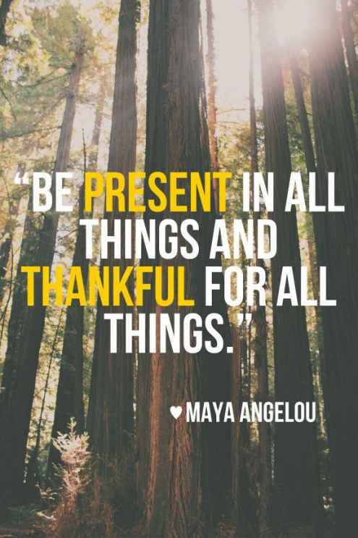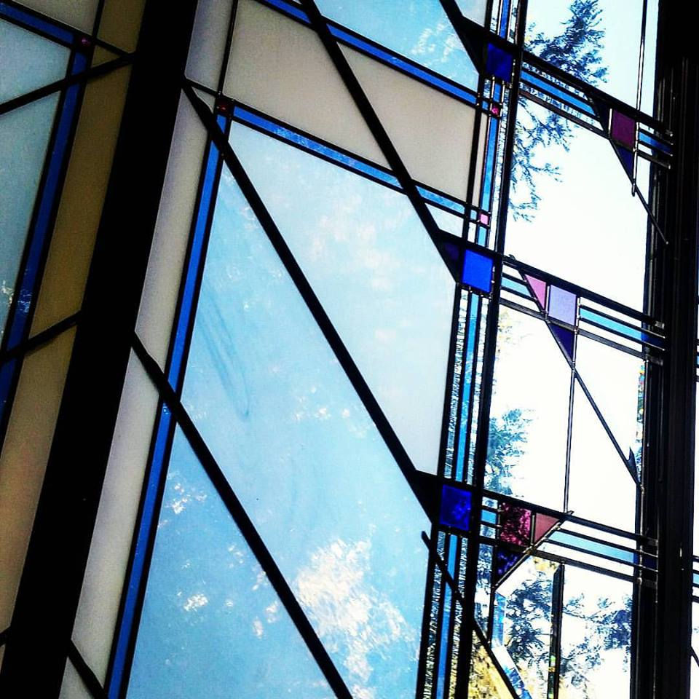

Shell Ridge Community Church

*A Progressive Faith Community in the East Bay*

Your source for catching up on the latest news, highlights, events, celebrations, and extra-curricular happenings going on in and around Shell Ridge Community Church in Walnut Creek, California.

**Ridge Runner**

Shell Ridge Community Church

200 La Casa Via  
Walnut Creek, CA 94598

SRCC Ridge Runner

OCTOBER 2016