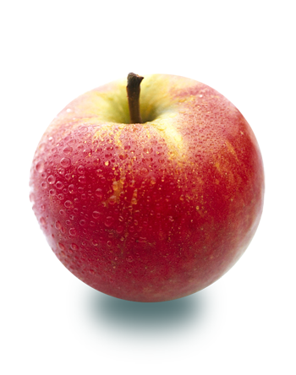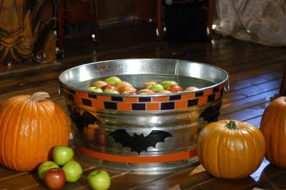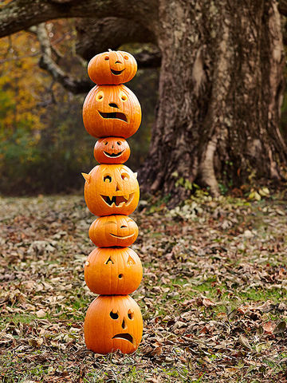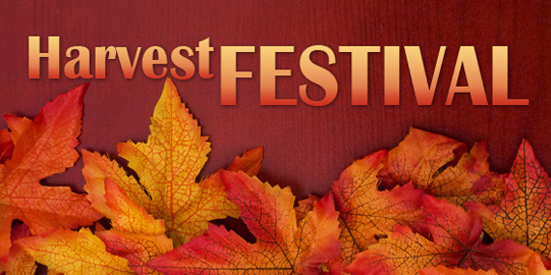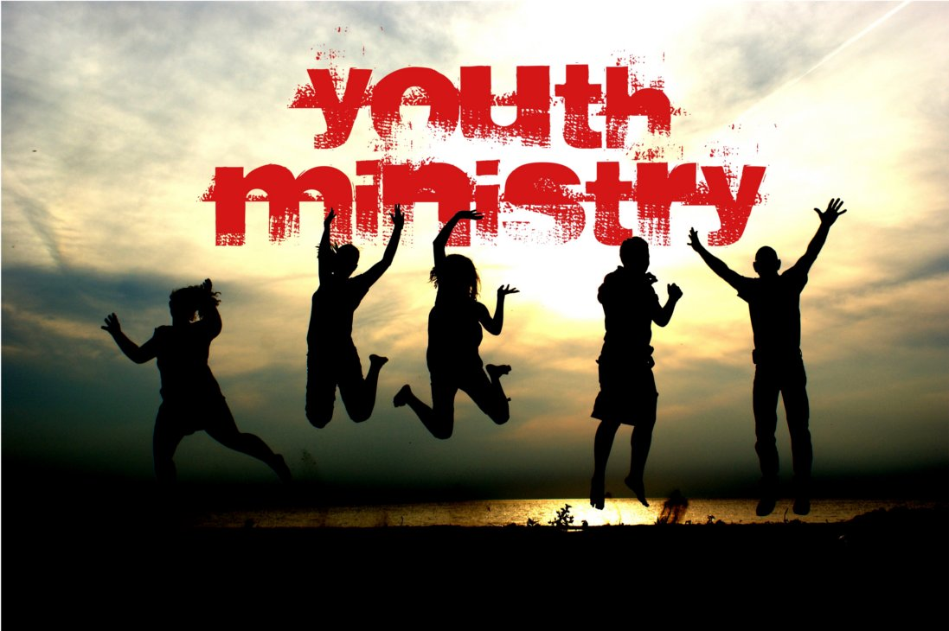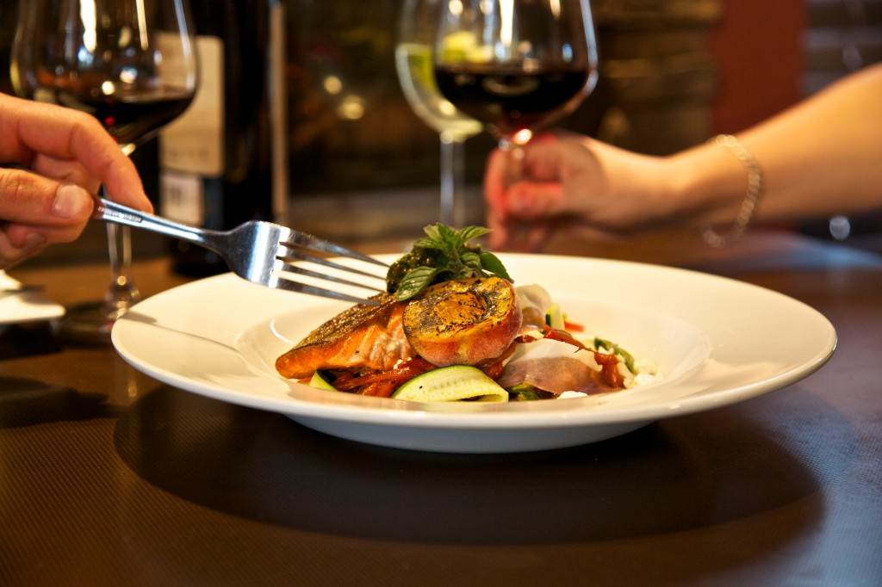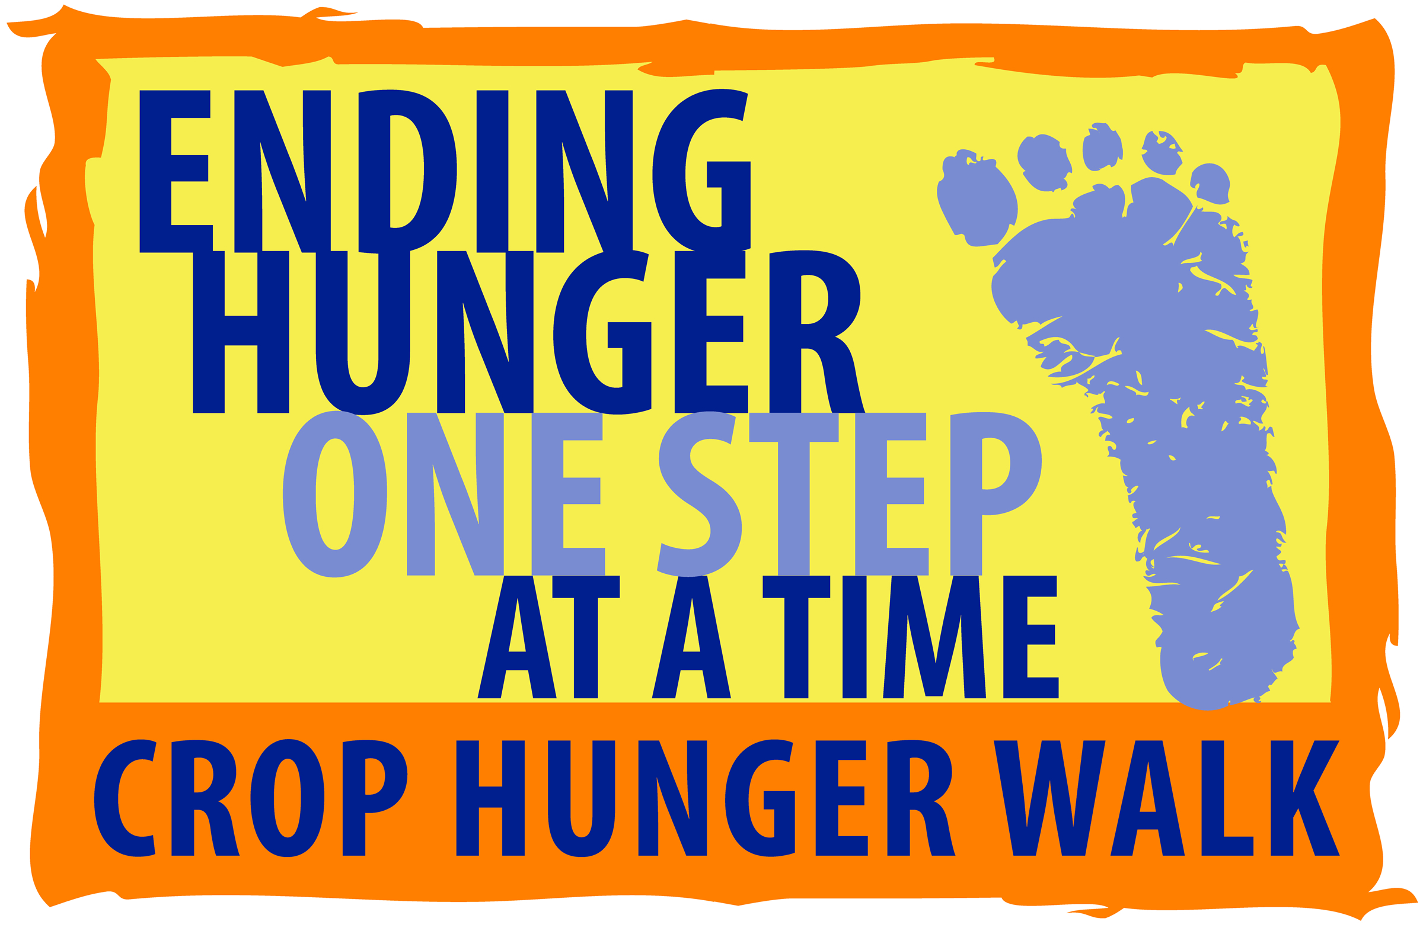

### The Beautiful Changes

## By Richard Wilbur

One wading a Fall meadow finds on all sides

The Queen Anne’s Lace lying like lilies

On water; it glides

So from the walker, it turns

Dry grass to a lake, as the slightest shade of you

Valleys my mind in fabulous blue Lucernes.

The beautiful changes as a forest is changed

By a chameleon’s tuning his skin to it;

As a mantis, arranged

On a green leaf, grows

Into it, makes the leaf leafier, and proves

Any greenness is deeper than anyone knows.

Your hands hold roses always in a way that says

They are not only yours; the beautiful changes

In such kind ways,

Wishing ever to sunder

Things and things’ selves for a second finding, to lose

For a moment all that it touches back to wonder.

### Words of Encouragement

**4**Rejoice in the Lord always; again I will say, Rejoice! **5**Let your gentleness be known to everyone. The Lord is near. **6**Do not worry about anything, but in everything by prayer and supplication with thanksgiving let your requests be made known to God. **7**And the peace of God, which surpasses all understanding, will guard your hearts and your minds in Christ Jesus.

**8**Finally, beloved whatever is true, whatever is honorable, whatever is just, whatever is pure, whatever is pleasing, whatever is commendable, if there is any excellence and if there is anything worthy of praise, think about these things.**9**Keep on doing the things that you have learned and received and heard and seen in me, and the God of peace will be with you. (Philippians 4:4-9)

3k fundraiser walk to end hunger. 1pm registration at event.

##### SRCC Harvest Festival

The Monthly Newsletter of Shell Ridge Community Church

##### Restaurant Walk

### the

Ridge Runner

OCTOBER 2016

Costumes, prizes, food, movies, silent auction, craft fair, music, etc.

Taste of Walnut Creek Restaurant Walk Fundraiser event.

10/16: 1:30PM

10/18: 6pm-9pm

10/29 – 3pm-5pm

##### Crop Hunger Walk

Did you know that a rope has greater strength than the combined individual strength of the strands that make it up? Why is this? The answer is quite simple. Individual strands have weak spots along them, points at which they easily break. But in a rope, the weak spots are randomly distributed along the length of the rope and the twist in the rope allows the surrounding strands to cancel out the weak spots of the individual fibers.

It’s the same with people. We all have strengths and weaknesses. On our own our weaknesses can break us, but together we work to achieve strength for all.

*Source: Scientific information from New Scientist magazine*

## It Takes a Tribe...

**Karen’s Corner**

There have been two senior gatherings in the past month, which, I wanted to let you all know about, and one that is upcoming. On August 14th, eight of us gathered for lunch at China Village following worship. We enjoyed good food and fellowship with some interesting conversation. Following worship on September 11th, we had a senior forum on the Challenges of Aging. This was spearheaded by Terry Burch and Bob Runyon and the third person on the panel was Pat Lavelle. There was much conversation about a number of issues that concern us seniors and it has served as a catalyst for an upcoming gathering on October 9th. After worship we will gather in the front of the sanctuary to continue our discussion with an emphasis on the housing issues that face many of us. The success of the first forum should be measured by the outpouring of enthusiasm for another forum and no one wanted to wait two months to do it. I think, from the response, that everyone is very interested and involved in these timely topics. It is also safe to say, that many felt it was a comfortable and safe place to express their concerns.  A special thanks to Terry and Bob and Pat for kicking this off and to all 39 of you who attended and shared in the discussion.

Always, Karen DeWeese.

**LET’S FEED THE KIDS**

A Multi-Faith ACTION Project with the Inter-Faith Council of Contra Costa County

The Pittsburg Family Center

**NEEDED IN October by the 23rd**

Diapers, sizes Newborn, 1, 2, 3, 4, and 5

and Fabric Softener Sheets

**URGENT NEED FOR UNSCENTED BABY WIPES!!**

***LOOKING AHEAD TO WINTER BREAK****...*

*(2 lb. 8 oz) jars of creamy peanut butter*

**Whenever we are asking for items to be donated, please bring them to church with you and place them in the narthex. (We check the space often.)**

Thanks for all you do as a part of Let’s Feed the KIDS.

Wendy Neale, Chr.

**No Kids Should Be Hungry**

# Rev. Carlton’s Notions

# “Ode to Octobers: Cool Breezes & Holiday Buzz”

Autumn is such a wonderful time of year. It is my absolute favorite time of year. For me, it elicits memories of my childhood in Maine of leaves turning and the cold setting in. It also reminds me of my very first memories of going to church. It was a quaint little American Baptist-USA church that was tucked away amid the pine and along the Kennebec River that stole my young heart. The church itself wasn’t stately, but it did have a New England air to it—white steepled bell tower and all. The pastor, Stafford Trapp, introduced me to countless stories of Jesus’ want to love the world and I still stand forever changed because of them.

Our Harvest Festivals were something of legend as well. They enlivened the neighborhood that surrounded the church. Friends, neighbors and strangers alike would grace that little neighborhood church dressed to the nines, music wafting, and children running wildly about. The hot cider never ran dry as if Jesus himself were there with us turning water about. The games were well thought and the baked goods were a holy welcome reminder that a season of festivity was upon us—that Thanksgiving, Christmas, and Easter were all lined up and at the ready.

I can still smell the apple cinnamon cake pouring out of the church kitchen—the homemade maple frosted doughnuts (Quebec like)—the center-pieced star anise and dried orange peels hanging on the air—the cobwebs and hay bales as well. I remember bobbing for apples, playing pumpkin tic-tac-toe and tossing the ol’ beanbags in the game of corn-hole.

As a child I adored seeing everyone dress up as well. From the elderly on down it became a shared tradition in the life of our church to let our guards down and get a little goofy before the celebratory seriousness of Advent and Lent set in. Some folks dressed as biblical characters and others as comic book characters. Some dressed up as sheroes and heroes and others chose more of a ghoulish route. We were, as a faith community alongside our neighbors, experiencing church more-so than in most instances I would argue. What is the church after all? We were unabashed and unashamed alongside one another. We didn’t give into pretense, nor did we camp out on burnt bridges. Quite to the contrary we shared in communion and mended ‘em.

There’s something about being silly that brings out the best in us. Laughter is such a sweet sweet medicine for the soul. I feel so very close to those I laugh alongside. In a world that seems to be preoccupied with despair (and despair has its place) it is good to remember not to take one’s self so seriously—to dress up and pretend—to break sweet breads and to laugh where laughter is needed.

Jesus ate sweets. I am sure of it. He even laughed. It is very much part of the human condition after all. Jesus, as we know, celebrated. He was not averse to having a good time and saw it as wholly important it should be argued. Every time I celebrate in communion I envision Jesus saying, “you’ve got it all wrong,” what I meant was eat actual meals together—organically gather—let your guards down—laugh a little and cry when necessary. Why? because life is far too precarious to be wasted conventionally. You won’t always have others around. Each and every one of you is a gift to that of the other. Take in the season and get loose.

Please make it a point to join us on October 29th from Shell Ridge’s first Harvest Festival celebration. This intergenerational and family fun event will leave you wanting to do it again.

Throughout the church property there will be time for games, snacks (hot cider, cocoa, coffee, and homemade doughnuts provided), Halloween movies, pumpkin carving, space set aside for Autumn/Christmas type crafts to be sold/purchased, a silent auction, bobbing for apples, fake spiders dangling... the whole nine-yards.

There will also be a costume contest of which Pastor Jeremy will judge the costumes. There will be prizes for *Best Dressed Couple, Most Creative, and most Ghoulish.* So, please get those creative juices flowing now and start thinking about what you’re going to wear. Your outfit might take some time to prep.

Also, though some snacks will be provided, you can bring a cake-like item (cookies, cake, pie, etc.) for our bake sale.

Max participation will make for a truly memorable event for us, so please, make it a point to come and be involved. This is not going to be an event that you’ll wanna miss.

All proceeds will be going to the Christmas Party and holiday season as we are hoping to use that time to reach out to the broader community and bring their attention to what Shell Ridge has been up to and the direction it is heading.

# SRCC HARVEST FESTIVAL 2016

# 1st Annual – Oct. 29th from 3-5PM

**KIDS CAN CLUB**

Wednesdays 5:00PM – 7:00PM

Weekly Themes:

**Oct. 5th Theology of Futurama: God of Mañana**

- Why worry or wonder about tomorrow?

**Oct. 12 The Theology of Now: Divine Intuition**

- Can we really feel the world around us?

**Oct 19th TBD (Crop Walk 10/16?) TBD**

**Oct. 26th Costume Making 101: God & Halloween**

- Why do the arts matter?

Wednesdays 5:00PM – 7:00PM

Kids ages kindergarten thru sixth grade are more than welcome to come and participate. Our kids will enjoy crafts, games, music, drama, and Bible stories. So please feel free to invite your friends and loved ones.

Kids Can Club Weekly Themes:

10/5     Talent Night

10/12   Celebrating Birthdays (July - Dec.)

10/19   Germany

10/26   Halloween

Sundays 9:30AM – 10:20AM

For the month of October Rev. Dr. Willis Shotwell will be teaching through the book of Romans. You won’t want to miss this wonderful opportunity! His scholarship, kindness, and whit are a true joy. This series will not leave you disappointed.

# SRCC Education

## Youth

## Adult Forum

When things in your lives seem almost too much to handle, when 24 hours in a day are not enough, remember the mayonnaise jar and the two cups of coffee.

A professor stood before his philosophy class and had some items in front of him. When the class began, he wordlessly picked up a very large and empty mayonnaise jar and proceeded to fill it with golf balls. He then asked the students if the jar was full. They agreed that it was.

The professor then picked up a box of pebbles and poured them into the jar. He shook the jar lightly. The pebbles rolled into the open areas between the golf balls. He then asked the students again if the jar was full. They agreed it was.

The professor next picked up a box of sand and poured it into the jar. Of course, the sand filled up everything else. He asked once more if the jar was full. The students responded with an unanimous "yes."

The professor then produced two cups of coffee from under the table and poured the entire contents into the jar, effectively filling the empty space between the sand. The students laughed.

"Now," said the professor as the laughter subsided, "I want you to recognize that this jar represents your life. The golf balls are the important things — your family,

children, your health, your friends and your favorite passions — and if everything else was lost and only they remained, your life would still be full. The pebbles are the other things that matter like your job, your house and your car. The sand is everything else — the small stuff.

"If you put the sand into the jar first," he continued, "there is no room for the pebbles or the golf balls. The same goes for life. If you spend all your time and energy on the small stuff you will never have room for the things that are important to you.

"Pay attention to the things that are critical to your happiness. Play with your children. Take time to get medical checkups. Take your spouse out to dinner. Play another 18. There will always be time to clean the house and fix the disposal. Take care of the golf balls first — the things that really matter. Set your priorities. The rest is just sand."

One of the students raised her hand and inquired what the coffee represented.

The professor smiled. "I'm glad you asked. It just goes to show you that no matter how full your life may seem, there's always room for a couple of cups of coffee with a friend."

# “Jar of Life” (Author Unknown)

**CONTRA COASTA CROP**

**HUNGER WALK (10/16)**

Join us on Sunday, October 16th for Contra Costa’s annual CROP Hunger Walk, sponsored by Church World Service! With its inception in 1969, CROP Hunger Walks are viewed by many as the grand-daddy of charity walks. The walk’s legacy is deeply entrenched even in our own community; since 1991, our community has raised over $300k through 40+ local groups. We walk to protest resource injustices, to protect and provide for our vulnerable, to build community, and to show solidarity in a time of divisiveness. To show our unified front on this cause, make sure to wear a CROP Hunger Walk t-shirts if you have one on walk day!   
  
The Contra Costa CROP Hunger Walk is one of 1,000+ across the nation, symbolizing the walk many around the world must make for basic resources such as food, water, shelter and protection. In a world where there is enough food for all, we are moved to action by the fact that one out of every nine people goes to bed hungry each night. With our combined national efforts, we raise around $10 million annually towards the shared mission of ending this worldwide inequity. Money raised supports food programs in emergency response, as well as longer-term solutions like enhancing food security and providing sustainable safe water supplies. In addition, 25 percent of funds raised stays in the community to bolster the local hunger-fighting efforts of Winter Nights.

**TASTE of WALNUT CREEK**

**RESTAURANT WALK 2016 (10/18)**

The Original Walking Tour of Downtown Walnut Creek Restaurants TUESDAY, OCTOBER 18, 2016, 6:00 to 9:00 p.m. Proceeds Benefit American Association of University Women (AAUW) Orinda Moraga Lafayette (OML) Branch, TECH TREK STEM, Summer Camp and Scholarships.   
  
Ticket Books will be available for purchase for $30 per person before October 10, 2016 from Sandy Mitchell, Karen Duran, and Avaril Woodward. Please contact them if interested.  
  
This event supports Congregation B'nai Tikvah, *Shell Ridge Community Church*, Orinda-Moraga-Lafayette Branch of the American Association of University Women, Mt. Diablo Unitarian Universalist Church.

**Ongoing Events in the Life of Shell Ridge:**

***Men’s Breakfast*** takes place every other Friday at 8:00AM at the Black Bear Diner in Walnut Creek (see the church calendar on the church website for exact days). Join us as we take on more calories than we should, drink more coffee than most mornings, discuss cars, scars, and whatever fits our fancy on a given Friday morning, and laugh together. It is truly an enriching time. We hope to see you there. For further details contact Pastor Jeremy. See you on Oct. 14th and 28th.

***Forum on the Challenges of Aging***

(Second Official Gathering) Sunday, October 9th, 2016

Time: Following the Church Service

Place: Sanctuary Alcove

Led by Darby Lockett and Bob Runyon (among others)

What? A forum designed for the older members and friends of the church for a post-service discussion on the challenges of aging.

__________________________________________________________________________

**Misc. General Housekeeping**

Reminder: The official church email is now [shellridgecommunitychurch@gmail.com](mailto:shellridgecommunitychurch@gmail.com)

When wanting to make announcements before the prelude during the church service please make it a point to sit up toward the front for the sake of time. Thanks!

If you are wanting to use tables from the church for any reason please make it a point to sign up for them beforehand via the sign-up sheet in the back of the sanctuary.

If you would like to share special music during our offering time, or during the church service please sign up for a particular Sunday using the sign-up sheet that is also located in the back of the sanctuary.

Please note that all announcements that pertain to the church bulletin need to be submitted by Thursdays at Noon. Similarly, all announcements for the monthly Ridge Runner need to be submitted by the Third Sunday of the month. Submit information to [shellridgecommunitychurch@gmail.org](mailto:shellridgecommunitychurch@gmail.org) or contact Pastor Jeremy elsewise.

___________________________________________________________________________________

“Thank you to Carrie Butler & Carol Eklund for leading us in worship on Sunday, September 18th! It was a true joy and a change of pace. We are already looking forward to the next time.”

“Thank you to Marilyn Michelson, Tim Michelson, Letina Shumaker, Dick Shumaker, Meg Verga, Sean McLaren, Jim Eklund, Valdo Columbo, Steffan Sedar, Sara Carlton, Avery Carlton, and Lura Bublitz for volunteering for the church-wide work day. We got a lot accomplished. The grounds and sanctuary look fantastic!”

**OCTOBER’S ADULT FORUM SCHEDULE**

October 2 - Communion Sunday - No children's Sunday School, nursery provided

October 9 – Rev. Dr. Willis Shotwell

October 16 - Rev. Dr. Willis Shotwell

October 23 - Rev. Dr. Willis Shotwell

October 30 - Rev. Dr. Willis Shotwell

**OCTOBER’S SUNDAY SCHOOL TEACHERS**

October 2 - Communion Sunday - No children's Sunday School, nursery provided

October 9 - Lesa Adams

October 16 - Sara Carlton

October 23 - Barbara Clarkson

October 30 - Sandy Mitchell

**OCTOBER’S USHERS**

October 2 - Communion Sunday – Sean McLaren, Jane Brock, William & Susy Fuentes

October 9 – Karen Duran, Lorraine Raffaelli, Lura Bublitz, and Nancy Smith

October 16 – Tim & Marilyn Michelson, Mary Hogan, and Valdo Columbo

October 23 – Meg Verga, Chris Verga, and Dick & Lenita Shumaker

October 30 – Youth Group (or) Lee & Jessie Heagle

|  |  |  |
| --- | --- | --- |
| **OCTOBER BIRTHDAYS** |  |  |
| Suarez | Christian | 4-Oct |
| Sedar | Steffan, Jr. | 8-Oct |
| Harris | Millie | 11-Oct |
| Kearins | Brian | 11-Oct |
| Wilcox | Sarah | 11-Oct |
| Hindes | Laura B. | 17-Oct |
| Holmes | Micky | 18-Oct |
| Kim | Jinoh | 18-Oct |
| Wilcox | Chase | 23-Oct |
| Fuentes | Alcides | 24-Oct |
| Mansoori | Laura | 24-Oct |
| DeWeese | Karen | 30-Oct |
|  |  |  |

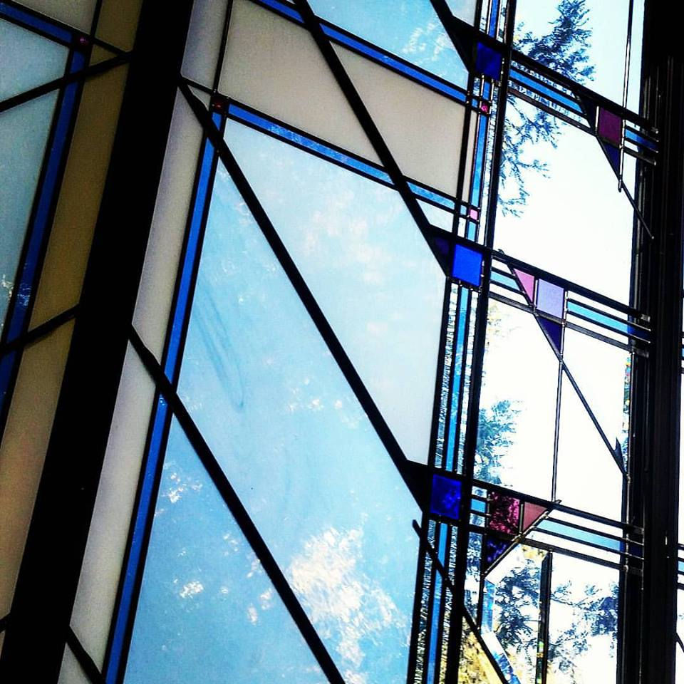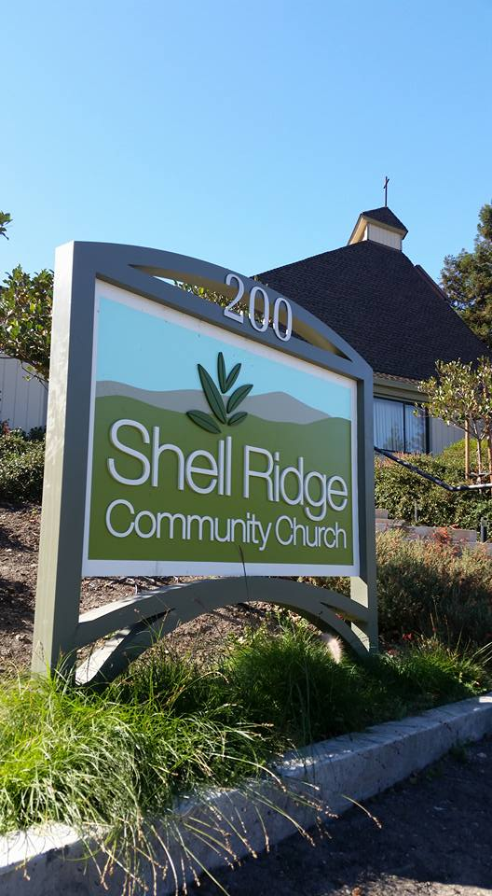

Shell Ridge Community Church

*A Progressive Faith Community in the East Bay*

Your source for catching up on the latest news, highlights, events, celebrations, and extra-curricular happenings going on in and around Shell Ridge Community Church in Walnut Creek, California.

**Ridge Runner**

Shell Ridge Community Church

200 La Casa Via  
Walnut Creek, CA 94598

SRCC Ridge Runner

OCTOBER 2016