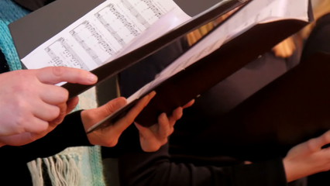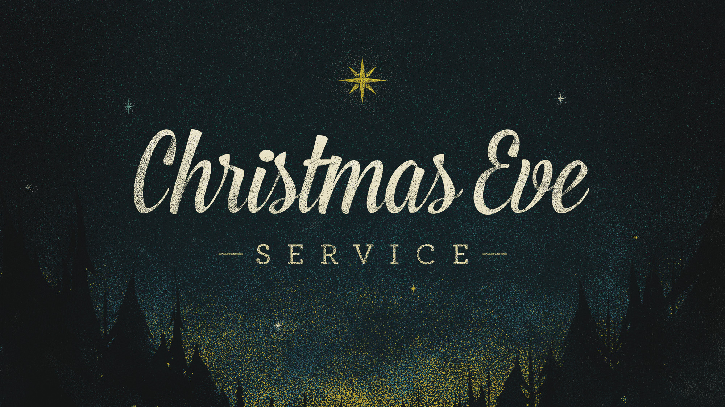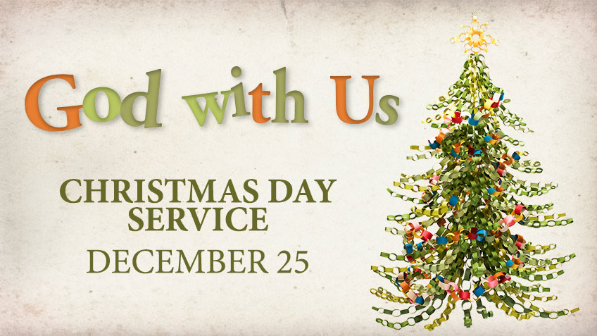

Join us as we celebrate the season together. 12/10/16 from 6PM-8PM

##### Christmas Eve Service

### Peace Matters

**“At one time, most of my friends could hear the bell, but as years passed, it fell silent for all of them. Even Sarah found one Christmas that she could no longer hear its sweet sound. Though I've grown old, the bell still rings for me, as it does for all who truly believe.” ― Chris Van Allsburg, The Polar Express**

# Do you remember?

Join us as we share in a very special candlelit church service on 12/24/16 at 5PM

Join us as we listen to the John Muir Chorus perform on on 12/14/16 at 7PM

Monthly Newsletter of Shell Ridge Community Church

the

Ridge Runner

And, lo, the angel of the Lord came upon them, and the glory of the Lord shone round about them: and they were sore afraid. And the angel said unto them, Fear not: for, behold, I bring you good tidings of great joy, which shall be to all people. For unto you is born this day in the city of David a Saviour, which is Christ the Lord. And this shall be a sign unto you; Ye shall find the babe wrapped in swaddling clothes, lying in a manger. And suddenly there was with the angel a multitude of the heavenly host praising God, and saying, "Glory to God in the highest, and on earth peace, good will toward people... Luke 2:9-14

#### Save the Date!

’16 Christmas Soirée

##### John Muir Chorus

December 2016

## 2016 Christmas Soirée

When: Saturday, Dec. 10th from 6-8PM Come enjoy a wonderful time of music, presentations, laughter, joy, and what will surely be some very memorable moments in the life of Shell Ridge.

Logistics: Finger food type potluck. Please bring a dish, plate, or item to share with everyone.

Lenita Shumaker will be squaring away a general sign up sheet during the next several Sundays with regard to food coordination so there's not a disproportionate amount of desserts (not that there is anything wrong with that of course).

## Women’s Lunch Bunch

After the worship service on Sunday, Dec. 4, all women are invited to Sandy Mitchell's home for a light lunch, followed by a time to put together small gifts for our children and youth. Our WEB (Women's Evening Bunch) has turned into Women's Lunch Bunch!

December 14th from 7:00PM Onward

Join us for an intimate evening of fun & entertainment! Free Admission

Invite a Friend, Colleague, and/or Associate.

*Note: Hot Cider & Cookies Provided*

John Muir Choir Performance

December 15th at 1:00PM

Enjoy a nice selection of treats, plus a program on "The Songs and Traditions of Christmas". Guests are especially welcome to join us for a delightful time  
Thanks to all who attended the Oct. 13 meeting. We learned a lot about the Meals on Wheels program. If you know of someone who could use a hot meal five days a week, have them call the MOW office to check out the program. They also collect sample sized toiletries to give to clients.  Bring those to church any time, especially after a trip!      
   
For more info, contact Darby Lockett 954-7522 or  
Elizabeth Burch 938-6282.

ABWM Christmas Dessert Social

# The Sock Tree

###### Each year a Sock Tree is set up in the Narthex by the American Baptist Women’s Ministry of Shell Community Ridge. We would warmly invite you to bring new pairs of socks on Sundays (or during the week) and hang them on the tree. Each pair of socks will be donated to those in need.

In recent months Rev. Carlton’s been stewing about what we might be able to do with regard to “doing justly” as a faith community over this holiday season. So, while in conversation with the Worship Team, they came up with the idea of putting trees up in the sanctuary over the holidays and encouraging folks to donate of their time, talent, and resources. Three trees had been selected and three causes therein. They are up now. One tree is wholly devoted to honoring our immediate neighbors (i.e. those who use our space... cp. Mom’s Day Out and the Russian Theatre). They use the playground regularly; but the “kid push & ride” toys are in certain disrepair. Jeremy has thrown out five of them in recent weeks due to safety concerns. So that tree will be used to replace those rides. Another tree is devoted to filling the backpacks that we have that we intend on handing out to the houseless. Under that tree folks are encouraged to leave toiletry type items in the demarcated boxes. The last tree has a sign-up sheet next to it for serving dinners to the houseless at Shelter, Inc. in Martinez, CA the last week of December. Point is; all of these trees are opportunities to give back—to love and do justly. Even if mobility is an issue you can still drop off some toothpaste or what not on Sundays. Whatever the case may be this’ll be a shared act of worship for many.

# Three Trees in the Sanctuary

Join us on Sundays (11/27-12/25) and on Christmas Eve this holiday season as we celebrate the Advent of Jesus together. In shared anticipation we will consider the story of Jesus’ birth and God as having become one of us in and thru him. Each Sunday we will be exploring various caveats of Jesus’ birth narrative at length. (Note: The SRCC choir will be performing weekly at each service thru Dec. 24th, 2016),

Join us Christmas morning at 10:30AM for a very special Christmas Day Service. The service itself will be shorter than normal, but it will be extra special given its depth of meaning. Join us as we share in celebrating our incarnational God’s want to become one of us—to practice the kind of solidarity that gives life to the broken, hope to the hopeless, and peace to the trepid.

## Christmas Day Service

# Special Upcoming

# SRCC Church Services

## New Years Day Service

2017 will soon be upon us! Join us as we celebrate a brand new year on the heels of Jesus’ birth. “Facing Possibility with Panache” will serve as the theme for this particular Sunday. Come join us we celebrate newness and the future of Shell Ridge Community Church.

## Christmas Eve Service

Join us on Christmas Eve (5PM) as we share in a very special candle lighting service. The service itself will be quiet and contemplative. It will also be filled symbolism, music, and a short homily. This is a great way to usher in Christmas morning—by wrapping our minds around Jesus’ coming the night before.

## Advent Season

# Rev. Carlton’s Notions

# “This Country’s Roads”

Road trips will always have my heart. I love the open road—the freedom. Seeing new places, meeting new faces, and experiencing things as if for the very first time revitalizes me. I also hate flying; so the open road has certain appeal. It stands to reason. For me, driving out in the middle of the desert is totally cathartic. I enjoy the company of tumbleweeds, hawks on posts, and rumbling tractor-trailers. I like drab run down towns, middle-of-nowhere gimmick shops (think Akela Flats or Little America), and California “check points.” “Do you have any fruits or vegetables,” they say. I say no, but the orange in my paper bag says much more. I don’t think it’s a big deal, but than several miles down the interstate I find myself debating about the moral fabric of my psyche and the society in which we live. I also love how very different our vast beautiful country is. And it is. From Hackberry Draw in west Texas to the camper community of Quartzite, Arizona there is beauty.

Beauty abounds. On the heels of a particular vitriolic election cycle, I was fortunate enough to see all walks of life—coming—going—eating—laughing—crying... and yes, passionately debating politics here and there. Now, I am not one to talk too much about politics, and I am especially mindful of how very important it is to separate church and state, but I must say that this road trip gave me profound hope in light of recent events. Despite our differences we tend to work it out. Somehow. Some way. America always has. This vast melting pot—this experiment—has seen its downs, but has certainly shared in enumerable ups comparatively. I tend to believe that the good has outweighed the bad. We’ve come a long way, and yes, there is much to be done, but taking in all the goodness that surrounds us on a daily basis truly has its place. The pessimist in me wants to deny this, but deep down I do believe that society as a whole is getting better.

Although it may not always seem like it, when I drive around this country I see an unrivaled desire for most of us to want to work it out—to be present with each other. For example, I made the acquaintance of a Hells Angel in Benson, AZ who held the door for me. As we waited there in line we enjoyed a good laugh or two. It felt surreal. While in Texas I chatted with theologians from all over the world (Gail O’Day, Bart Ehrman, Cornell West, etc). I thanked countless cops in San Antonio for their service in uniform in having just lost one of their own from senseless violence. I had dinner with a stranger named Ashley (recent PhD grad) who is now my friend on Facebook. I even met Julian Castro (US Sec. HUD). A teenager explained a very complex video game in all its detail to me for literally an hour on Phoenix. I even managed to accidently crash a family’s quinceañera. They were kind and shared some ice cream with me. Point is, no matter how messy it gets (politically, philosophically, theologically, etc) we’re all in this together. I am confident that each and every person I met had a different outlook on life than I did. Though different, there was a mutual appreciation at play just below the surface. I am not saying that we should turn a blind eye to justice here. No. Not at all. What I am saying is that in order for justice to be realized altogether we must share in life. Yes, it felt out of place here and there, but that is exactly where justice takes shape... amid the discomfort and in light of my ignorance.

So, in the spirit of channeling James Taylor I will end with these lyrics... “Take to the highway, won't you lend me your name? Your way and my way seem to be one and the same. Mamma don't understand it, she wants to know where I've been. I'd have to be some kind of natural born fool to want to pass that way again, But I could feel it on a country road.” The gospel—justice really, has everything to do with shared roads.

**LET’S FEED THE KIDS and FOOD FOR THOUGHT**

Winter Break

December 12-14, 2016

10:00 each morning

Temple Beth Hillel

Carpooling from Shell Ridge

Leaving at @9:15 am

PROVIDING FOOD FOR CHILDREN IN THE RICHMOND SCHOOLS

**Monday, 12/12 -**  Build Boxes

**Tuesday, 12/13 -** food will be sorted and packed -- LOTS OF VOLUNTEERS ARE NEEDED!

**Wednesday, 12/14 -**  the food boxes will be delivered to the Richmond schools (volunteers need to be able to lift boxes (no back problems).

Please e-mail Wendy Neale ([wjneale@earthlink.net](mailto:wjneale@earthlink.net)) or see her at church to sign up to be a volunteer. Sandy Mitchell, Mary Hogan, or Betty deKat can answer any questions you may have also.

Money donations are always appreciated. Please write checks to Shell Ridge Community Church – Write LFTK (or Let’s Feed the KIDS) in the memo and

mail your donation gifts to the church or place it in the offering plates by Sunday, December 11.

This project will help feed kids during their winter break when they do not receive federally funded breakfasts and lunches. 150 kids and their families will be provided with beans, rice, pasta, canned goods, peanut butter, fresh vegetables and fruits, breads and hopefully some goodies too.

The peanut butter drive continues until December 11!! So far we have 90 jars!! Yeh!

Thank you for your time, your donations and your prayers.

**No Kids Should Be Hungry**

Young, Gwendolyn

1905 Stratton Cir.

Walnut Creek, CA 94598

Cell: 440 - 858 – 3752

[gyygwen@gmail.com](mailto:gyygwen@gmail.com)

***DECEMBER – SUNDAY SCHOOL VOLUNTEERS***

Dec 4 - Communion Sunday - no children's Sunday school - nursery available

Dec 11 - Lesa Adams

Dec 18 - Sandy Mitchell

Dec 25 - Children stay in service with family

***DECEMBER – ADULT FORUM HAS BEEN CANCELLED FOR THE MONTH DUE TO CHOIR***

***DECEMBER’S USHERS:***

Nov 6 - Communion Sunday – Sean McLaren, Jane Brock, William & Susy Fuentes

Nov 13 – Karen Duran, Lorraine Raffaelli, Lura Bublitz, and Nancy Smith

Nov 20 – Tim & Marilyn Michelson, Mary Hogan, and Valdo Columbo

Nov 27 – Meg Verga, Chris Verga, and Dick & Lenita Shumaker

***DECEMBER BIRTHDAYS:***

**NEW ADRESSES & UPDATES:**

Carter, Roy & Andrea (Andi)

3928 Mac Arthur Blvd., #B

Oakland, CA 94619

A) cell: 559 - 977 - 8822

R) cell: 415 - 944 - 0565

email:

A) [andihindes@hotmail.com](mailto:andihindes@hotmail.com" \t "_blank)

|  |  |  |
| --- | --- | --- |
| Name | | Date |
|  |  |  |
| Mason | Corrine | 4-Dec |
| Wilcox | Lily | 4-Dec |
| Tun | Pray | 6-Dec |
| Granquist | Jan | 7-Dec |
| Zink | Janet | 9-Dec |
| Hogan | Bob | 13-Dec |
| Lockett | Darby | 24-Dec |
| Tharalsen | Cathy | 24-Dec |
| Mansoori | Russ | 26-Dec |
| Burdette | Danielle | 27-Dec |
| Bernales | Dezarina | 27-Dec |
| Duran | Karen | 28-Dec |
| Heagle | Lee | 31-Dec |

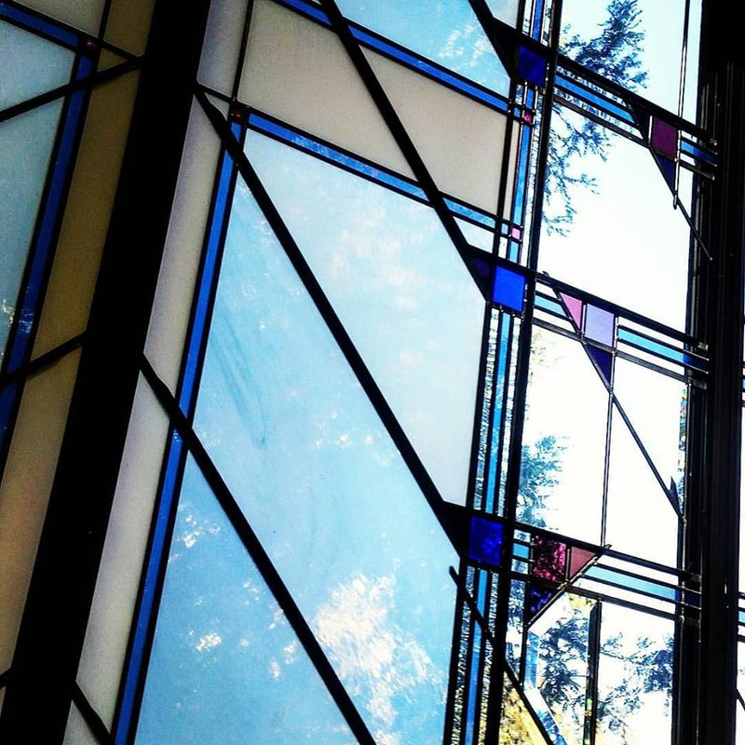

*A Progressive Faith Community in the East Bay*

Your source for catching up on the latest news, highlights, events, celebrations, and extra-curricular happenings going on in and around Shell Ridge Community Church in Walnut Creek, California.

**www.shellridgecommunitychurch.org**

**Shell Ridge Community Church**

Ridge Runner

Winter 2016

SRCC RIDGE RUNNER

Shell Ridge Community Church

200 La Casa Via  
Walnut Creek, CA 94598