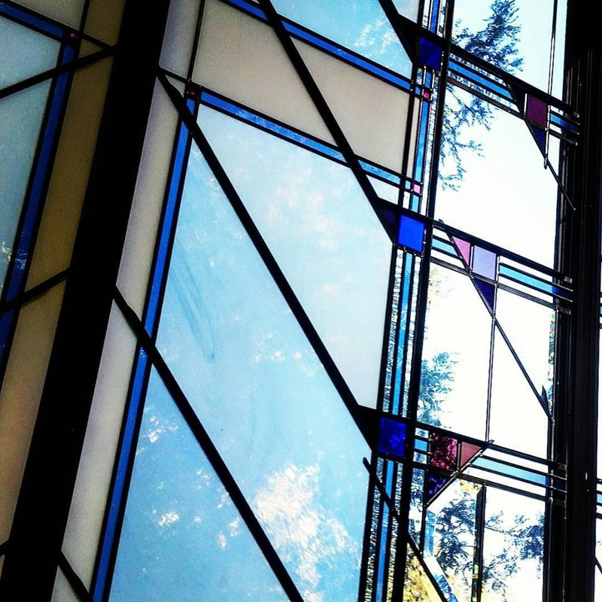

# **Psalm 126:2-3 (NIV)**

**2**Our mouths were filled with laughter,  
    our tongues with songs of joy.  
Then it was said among the nations,  
    “The Lord has done great things for them.” **3**The Lord has done great things for us, and we are filled with joy.

THIS SUNDAY (7/2): Congregational ‘Hymn Sing’ led by our very own Mary Hogan.

NEXT SUNDAY (7/9) Special Guest preacher Rev. Nancy Smith will be preaching and a Special Forum on “Diffusing Hatred” to follow which will be led by Rev. Will McGarvey. Light lunch provided.

***“The whole wilderness in unity and interrelation is alive and familiar … the very stones seem talkative, sympathetic, brotherly. … No particle is ever wasted or worn out but eternally flowing from use to use.”*** *~John Muir in My First Summer in the Sierra, 1869*

Upcoming Opportunities

A Progressive Faith Community in the East Bay

SUMMER 2017

Quarterly Ridge Runner Newsletter (July – Sept.)

Community Church

Shell Ridge



**[Tentative] UPCOMING 2017 SUMMER SCHOLAR SERIES**

August – Exact Date & Time TBD

Topic: What does it mean to flourish as an individual?

Speaker: Dr. Brooks Thome, Psychologist, PsyD, LMFT, CSAT

Dr. Thome’s “work revolves around helping clients make lasting changes in their lives. Those who seek [his] services do so because they are dealing with complex problems and they want to experience change. Often these problems include relationship difficulties, healing past trauma or betrayal, pursuing recovery from addictive behaviors, developing a positive self-image, decreasing feelings of anxiety and depression, desiring to grow spiritually, and many other issues where they wish for change in order to experience a flourishing life.” More info to come.

**Your Mercy and Justice Team invites YOU to a Special Forum  
“KEEP CALM AND DEFUSE THE TENSION”**  
   
**Sunday, July 9**, following our worship service you are invited to have a light lunch followed by a program on **Defusing Hatred**.  Come learn nonviolent communication skills in a safe environment and develop tools for responding to uneasy situations and hate speech. Enjoy an informative, visual presentation and discussion by the Rev. Will McGarvey, Executive Director of the Interfaith Council of Contra Costa County, and his team.

**Please join us.**  
   
   ~ Wendy, Barbara, Cindy, Susy, William, & Mary

### Join us for an enriching time

### led by Rev. Will McGarvey

“Keep Calm and Diffuse the Tension” Forum scheduled for July 9th at Noon

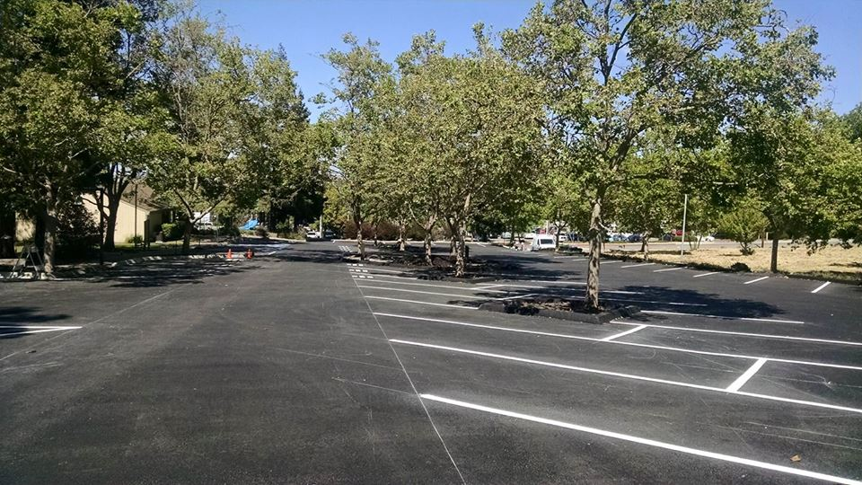

# **Colossians 1:15-20**

**15**The Son (Christ) is the image of the invisible God, the firstborn over all creation. **16**For in him all things were created: things in heaven and on earth, visible and invisible, whether thrones or powers or rulers or authorities; all things have been created through him and for him. **17**He is before all things, and in him all things hold together. **18**And he is the head of the body, the church; he is the beginning and the firstborn from among the dead, so that in everything he might have the supremacy.**19**For God was pleased to have all his fullness dwell in him, **20**and through him to reconcile to himself all things, whether things on earth or things in heaven, by making peace...

**Pastor Jeremy’s Thoughts as of Late**

I have been struck as of late by this wild notion that God came as Christ (in perfect solidarity) by means of the Holy Spirit to create cause for *O/our* *mutual flourishing*. This might sound like an old hat to many, but it has been a fascinating journey to think through as of late for me all the same and I thought, “where better to share my personal thoughts if not the Shell Ridge Community Church Ridge Runner itself.” So here goes.

I’ve spent decades believing in a form of classic deism that left God much farther than I’d let on—aloof yet periodically involved in the affairs of this earth. I have struggled greatly with this idea that the God of the Old Testament was, or at least could be, the same as that of Christ. I mean; what to make of all the genocide as compared to the selflessness of Jesus... the innocents and innocence lost... the vindication and what appears to be a short fuse as compared to Christ’s patience? And, here comes Jesus the Christ (the Salve’ior)—loving—humble—gentle—kind—compassionate—liberating. And, to top it all off; Jesus in experiencing our plight as a people[s] altogether leaves us with quite the parting gift; the Holy Spirit. Not too shabby if you ask me! Whether or not you have a high view of scripture, or a low view of scripture (or none at all), Jesus is a tale that is as old as time and there is definitely a reason as to why no other character in the last 2,000 years, in particular, has garnered as much attention. Jesus draws. The Spirit nudges. God the parent...?

When I think of my own personal flourishing I tend to immediately think of things like sound thought, good health, and certain security. Many do I’d suspect. Yet the degree to which each of us flourishes differs which is why injustice deserves our continued address. We are as weak as the weakest among us after all—as broken as the most shattered of lives. There is a corollary. We are all systemically related. I suppose what strikes me most about this whole flourishing thing is that it finds comforting resonance within the godhead itself. That God saw it fit to flourish too. Not only is our desire and aim to flourish and encourage mutual flourishing, but God desired/desires to flourish also... as God the parent... as God as Christ... and as God the Spirit (sophia/pnuema)... and might I add as God in and through each and every one of us also. As God’s children we share in that mutual flourishing that saw it fit to create, animate, and sustain the universe and all that’s in it. Wow! And to think; now God longs to flourish in and through us as we create and live into incredible possibility. Who would have thought but God? Cheers!

The **Seafarer’s Ministry of the Golden Gate** invites you to

**Celebrate Sea Sunday**

**Sunday July 9th, 2017**

4pm worship service honoring Seafarers

followed by an ice cream social

**International Maritime Center**

**4001 7th street, Oakland California**

**(near the port view park)**

For more information contact Nancy Smith

ABWM News

*January and July are our months for collecting****magazines for the county hospital****. Please bring magazines no older than two years and place them in the narthex. Be sure to remove your personal identifying information. At the end of the month, these magazines will be delivered to the county hospital for their patients and waiting room visitors. Foreign language magazines are greatly welcome.*

**NOTICE TO LFTK CONGREGATIONS:**

Let’s Feed the KIDS and Food for Thought want to thank you for all you have done for the last 3 years to help with Winter and Spring Breaks in the Richmond Schools. Not only have we been able to feed many kids and their families, but we have become interfaith friends working together for a good common cause. THANK YOU!!

We have made a decision that we want to share with you. We have decided to not do Spring Break in 2017, but focus our efforts on enlarging the scope of the Winter Break in December. We have set a goal of adding 3 new schools (exceeding this goal would be wonderful too). With Winter Break we have been able to provide food for 2 weeks, rather than 1 week for Spring Break; and also more schools presently are able to cooperate with Winter Break than Spring Break.

We look forward to accomplishing even more in December 2017 and working together with you and your congregation. Please pass the word.

Let’s start the Peanut Butter drive for next December 2017.  We will need even more than the 150 jars we collected for 2016

***It has been noted that Sam’s Club has 40 oz jars of peanut butter at 2 for $7.73 until July 14.  If you are not a Sam’s Club member, but would like to take advantage of this good price...Betty deKat will buy it for you (give her $8.00 in an envelope).  We have 70 jars so far...we need 200 by December.*  
  
Thank you,** **Wendy Neale**

***Summer Kids Club***

***(aka VBS... circa 1985)***

***Theme: “Catch the Wave”***

***JULY 10th – 14th***

***from 9:30 till Noon daily***



***Flyers are located on the Usher’s Table in the back. Please grab a few and invite a friend or two.***

***Registration forms are available through the church office.***

***Please contact Suzanne Smith if interested.***

***Church Office Phone: 925-935-3250***

**September Birthdays:**

|  |  |  |
| --- | --- | --- |
| Runyon | Bob | 2-Sep |
| Bishop | Bob | 3-Sep |
| Eklund | Lynn | 4-Sep |
| Verga | Chris | 4-Sep |
| Smith | Suzanne | 5-Sep |
| Granquist | Hal | 6-Sep |
| Kim | Sarah | 7-Sep |
| Burch | Terry | 18-Sep |
| Shumaker | Dick | 24-Sep |
| Raffaelli | Lorraine | 26-Sep |
| Smith | Kevin | 27-Sep |
| Vines | Richard | 27-Sep |
| Holmes | Doug | 29-Sep |
| White | Tina | 29-Sep |
| Ewing | Diane | 30-Sep |
| Lavelle | Pat | 30-Sep |

**UPCOMING BIRTHDAYS**

**July Birthdays:**

|  |  |  |
| --- | --- | --- |
| Name | | Date |
| Foust | Bette | 1-Jul |
| Kim | Joy | 3-Jul |
| Morrison | Zoe | 10-Jul |
| Hogan | Mary | 12-Jul |
| Stanek | Stan | 13-Jul |
| Phillips | Arlene | 19-Jul |
| Escareno | Dan | 21-Jul |
| Granquist | Dave | 22-Jul |
| Mitchell | Sandy | 24-Jul |
| Eklund | Carol | 26-Jul |
| Goldberg | Darcey | 30-Jul |

**August Birthdays:**

|  |  |  |
| --- | --- | --- |
| Fuentes | Susy | 6-Aug |
| Patton | Simone | 9-Aug |
| Duran | Elizabeth | 10-Aug |
| Heagle | Jessie | 12-Aug |
| Brock | Jane | 13-Aug |
| Shotwell | Willis | 22-Aug |
| Tun | Abigail | 23-Aug |
| Buttler | Carrie | 24-Aug |
| deSchroederKat | David | 25-Aug |
| Watson | Sean | 26-Aug |
| McLaren | Dylan | 29-Aug |

***A huge thank you to Sean McLaren and all those who volunteered to make sure that American Asphalt was ready to lay down our new parking lot at SRCC. It looks marvelous and is truly welcoming. Again, thank you to all those who helped make this possible and thank you to those who’ve donated thus far toward our $75k goal. If you would like to make a donation please contact the church office.***

**CHURCHWIDE LOGISTICS & REMINDERS**

Please refer to the church website ([**www.shellridgecommunitychurch.org**](http://www.shellridgecommunitychurch.org)) from now on concerning the ushers schedule, communion helpers schedule, monthly Adult Forum agenda/curriculum, children/youth programming, and church related policies and procedures. Also, please refer to the SRCC website’s calendar often for facility room use schedules (for SRCC proper [green] as well as guests [red]), event dates, meeting times, and general listings. (Note: Rest assured that your full names will not be made public; just your first names and the first initial of your last name.)

***Dear Church Family,***

***We are an open, welcoming church, and it is up to all of us to demonstrate that. Many times we have discussed this in council and in worship. We want visitors to feel comfortable in our sanctuary, but it is difficult for that to happen when they don’t have easy access to a seat. Please, if you are able-bodied, sit in the middle of the row so that the end of the rows (and back rows) are available to visitors. Your consideration of this will be most appreciated by all.***

***Sincerely, A Concerned Member***



Shell Ridge Community Church never ceases to amaze. We have seen visitors consistently coming to our church services throughout 2017 thus far and we would like you to consider one of two things as traction continues to take shape. Firstly, would you prayerfully consider coming and worshipping alongside us consistently (or perhaps all over again) as we embrace new and exciting programs, culturally relevant events, justice driven outreach, and inclusive worship? Secondly, if that were not a possibility would you consider spreading the word on our behalf and recommending us to others also? You could do so by referring a friend or neighbor our way, following us on Facebook (or other social media platforms), and/or simply letting folks know what we’ve been up to per these Ridge Runners. Again, it is an exciting time in the life of Shell Ridge. Will you do what you can? We sure would appreciate the boost.

Springtime Edition

Shell Ridge Community Church – Ridge Runner

Come grow with us!

200 La Casa Via

Walnut Creek, CA, 94598

925-935-3250

www.shellridgecommunitychurch.org

Community Church

Shell Ridge